# CS 255 System Design Document Template

This template lays out all the different sections that you need to complete for Project Two. Each section has guidance to prompt your thinking. You will need to continually reference the interview transcript as you work to make sure that you are addressing your client’s needs. There is no required length for the final document. Instead the goal is to complete each section based on what your client’s needs are. Remove this note when you are finished and replace all bracketed text with the relevant information.

## UML Diagrams

### UML Use Case Diagram

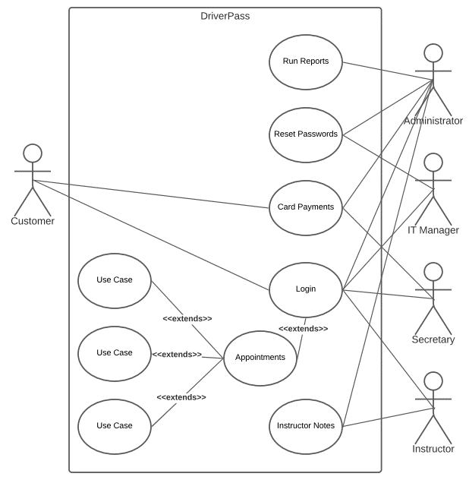

### UML Activity Diagrams

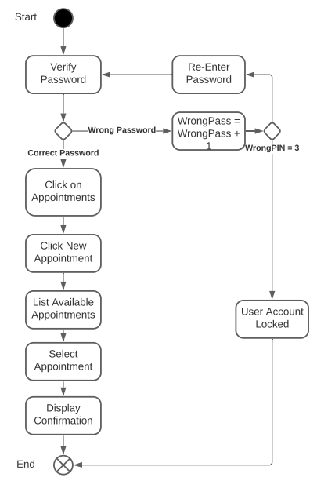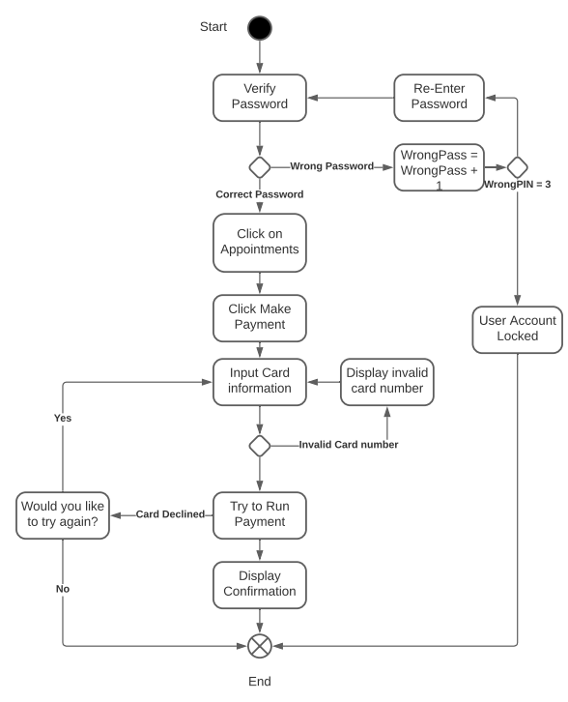

### UML Sequence Diagram

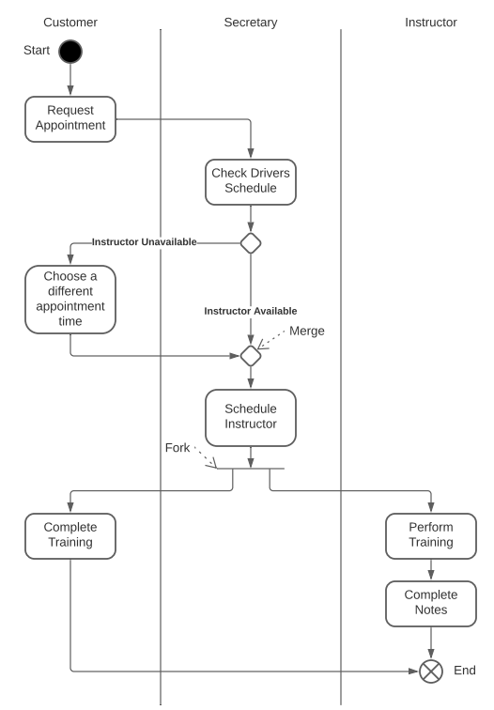

### UML Class Diagram

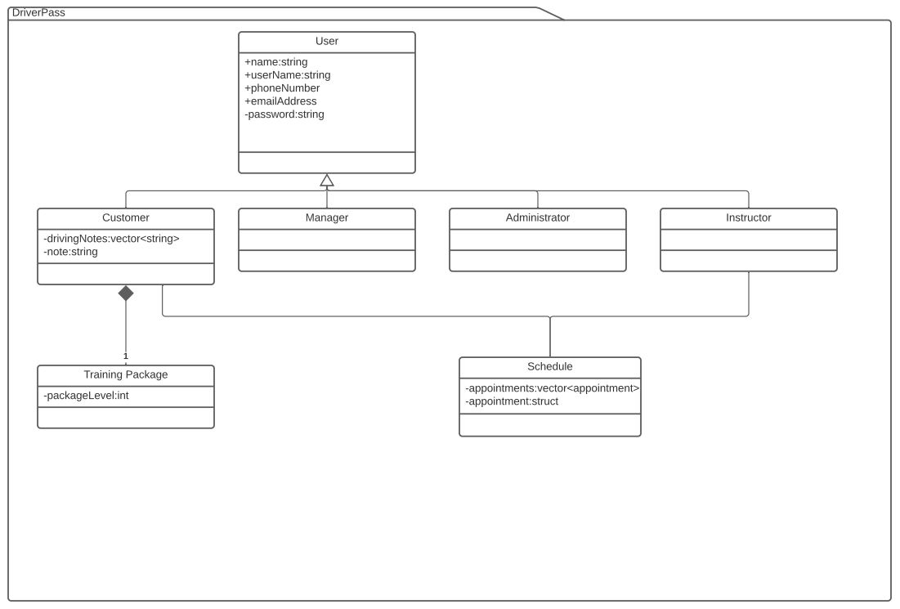

## Technical Requirements

In order to provide the necessary security and relational information the system will need the following infrastructure items. For network security an enterprise grade firewall will be necessary. A highspeed, symmetrical business internet connection will be needed with a backup internet connection through an LTE network or secondary internet service provider will be necessary to provide minimum downtime. A database server and a Unix webserver will be needed to store the site database and host the website. A network switch will be needed to setup communication between the different workstations and servers. Eternal and cloud storage will be necessary to keep consistent backups of the system in case of failure.